Screen Sketches

MS 317: Andrew de Gala, Brian Xicon, Dongho Kim, Siddhartha Gudipudi

WingWatcher

**Actors**

1. **Viewers: Have the privilege to:**

* Take a picture to classify and store.
* Access their phone’s storage for classification and storage.
* Declare if a bird has been found by the viewer or not.
* Access information about a specified bird (via search, list, or through the classification).
* Access pinpoints on a map which will give further information like date, time, and images taken.
* Access the profile page to change the user/user class.
* Log in to the app.

1. **Researchers: Have the same privileges as viewers in addition to:**

* Update information of birds.
* Access to range maps of the birds.
* Export bird database.
* Access to all map pinpoints from all users.
* Listen to bird calls.

1. **Administrators: Have the same privileges as researchers in addition to:**

* Access the admin panel page.
* Manager user accounts (create, modify, and delete).
* Access to analytics dashboard that provides an overview of user activity which includes the number of registered users, daily classifications, and bird sightings.

**Non-Functional Requirements**

* + - 1. **Performance**
* The application must be able to classify the bird within 10 seconds of the user request.
* The application must be able to respond to any UI element in .5 seconds or less.
  + - 1. **Reliability**
* The applications neural network must be able to classify a bird with a minimum accuracy of 80% using professional photography (not completely native pictures).
  + - 1. **Maintainability**
* The application must have a modular design to allow for easier updates and maintenance on specific parts of the application without affecting others.

**Tables and Fields**

1. **User Table: Tracks information related to a user’s account.**

* Primary Key: ID
* Fields: Username, Email, Hashed Password, Privilege (Viewer, Researcher, or Administrator)

1. **Bird Information Table: Information about birds to show user.**

* Primary Key: Scientific Name
* Fields: Name, Short Description, Images of Bird, Range Map, Bird Call

1. **Bird Tracking Table: Information about what type of bird a user scanned, when, and where.**

* Primary Key: Tracking ID
* Foreign Keys: User ID (to User Table), Scientific Name of Bird (to Bird Information Table)
* Fields: Latitude, Longitude, Date, Time, Image

1. **Analytics Table: Information for the administrator about the application**

* Primary Key: Analytics ID
* Foreign Key: User ID (to User Table)
* Fields: Date, Birds Classified on Date, Total Birds Classified

**Relationships**

1. **User Table & Bird Tracking Table**

* One-to-Many

1. **User Table & Analytics Table**

* One-to-Many

1. **Bird Information Table & Bird Tracking Table**

* One-to-Many

**Screen Flow Diagram**

**Screen Flow Visualization**

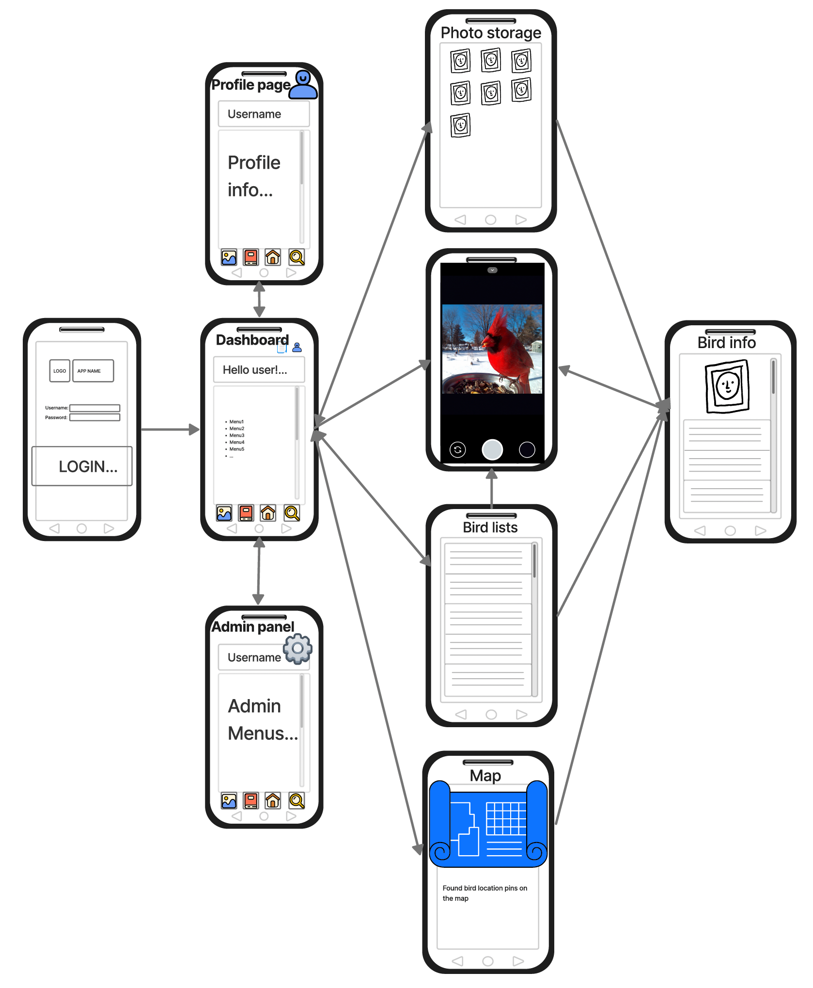

(Bird Info (Viewer Mode), Brian Xicon)

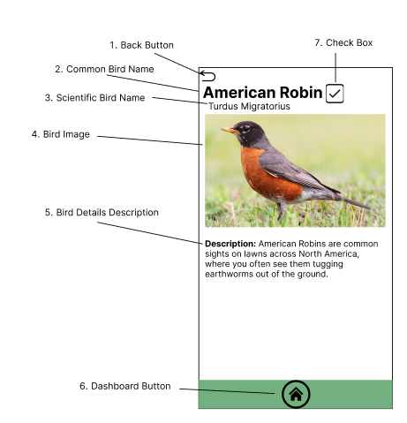

Figure 1: Bird Info (Viewer Mode) (Brian Xicon)

This screen is the viewer version of the bird information page. This is what will be shown to the user either after identifying a bird with the camera/storage or by searching for a specific bird in the list screen. The purpose of this screen is to give information about a bird to the user and is used to show the user what bird they took a picture of. It has a back button (1) which allows the user to go back to the list page. It then has the common (2) and scientific (3) name of the bird. Next it has an image of the bird (4) for the user to reference with the bird they classified. Then, it states a small description of the bird (5). Next, it has a button at the bottom which will allow the user to go back to the application’s dashboard. Lastly, it has a check box (7) which will indicate whether the user has found this bird or not.

(Bird Info (Researcher Mode), Brian Xicon)

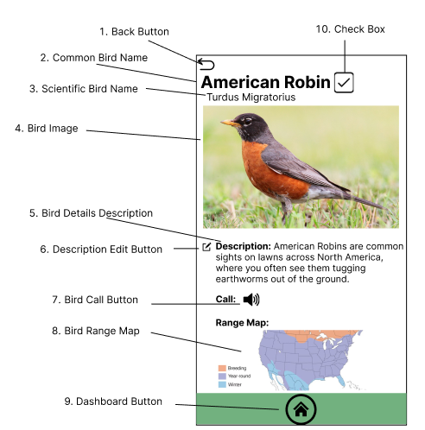

Figure 2: Bird Info (Researcher Mode) (Brian Xicon)

This screen is similar to the viewer version of the bird info page, but it has additional features just for the researcher actor. The features it reuses are the back button (1) which is used to go back to the bird list page, the common (2) and scientific (3) bird name. The bird image (4) is used for the user to reference the bird they identified. The bird details description (5) is used to give the user a short description of the bird. The dashboard button (9) is used to send the user back to the application’s dashboard, and the check box (10) is used to show the user whether they have found the specific bird or not. This concludes the features that the researcher mode shares with the viewer mode. The new additions are the description edit button (6) which will give the researcher the ability to change the text in the description which will update the entire database table. Next there is the bird call button (7) which will allow the researcher to listen to an audio clip of the bird’s call. Lastly, there is the bird range map (8) which will show the researcher where the bird is located and during which seasons in North America.

(Map, Brian Xicon)

Figure 3: Map (Brian Xicon)

This screens purpose is to give the user information about all the times they have observed a bird with our application. It will give them access to an entire map (1) which has bird observation points (2) which put together allows the user to see all the locations they have spotted a bird. The bird observation points also act as a button in which the user can press to pull up more information with the use of the information board (3). This is a pop up that will give additional information like the date, time, common bird name, and an image of the bird which is not only a visual but a button as well (6) that will take you to the corresponding bird info screen. The last button will be the dashboard button (4) which will just send the user back to the dashboard if pressed. The researcher/administrator will not only see the bird observation points they have made but also the bird observation points of all users.

(Photo Storage, Dongho Kim)

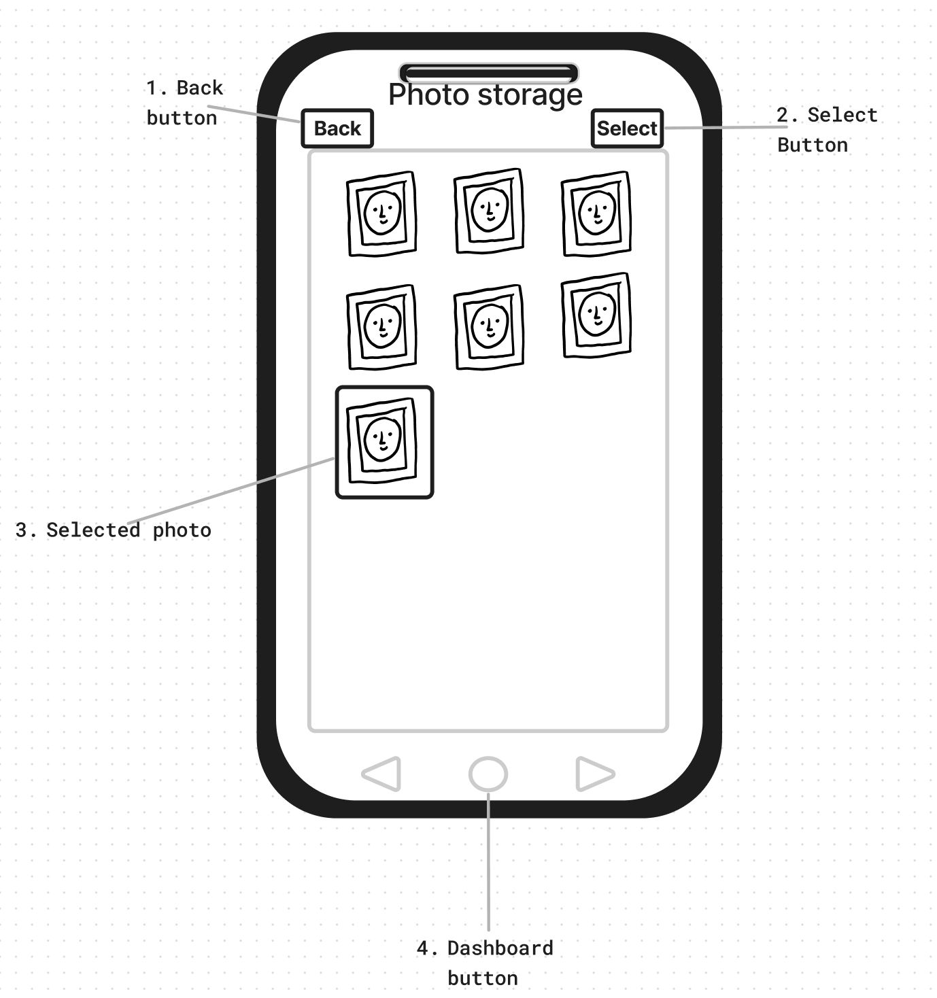

Figure 4: Photo storage (Dongho Kim)

Researchers and viewers can access this page by the photo storage menu from the User Dashboard page. This pages accesses and pulls up the photos stored in the local photo storage of the device. Back button and Dashboard button will prompt you to the User Dashboard page anytime **(1)**, **(4)**. Select a photo **(3)** and confirm it using the select button **(2)**, this will feed the selected photo to the Tensorflow API and return the detected bird info page, displaying the matching bird info.

(Camera, Dongho Kim)

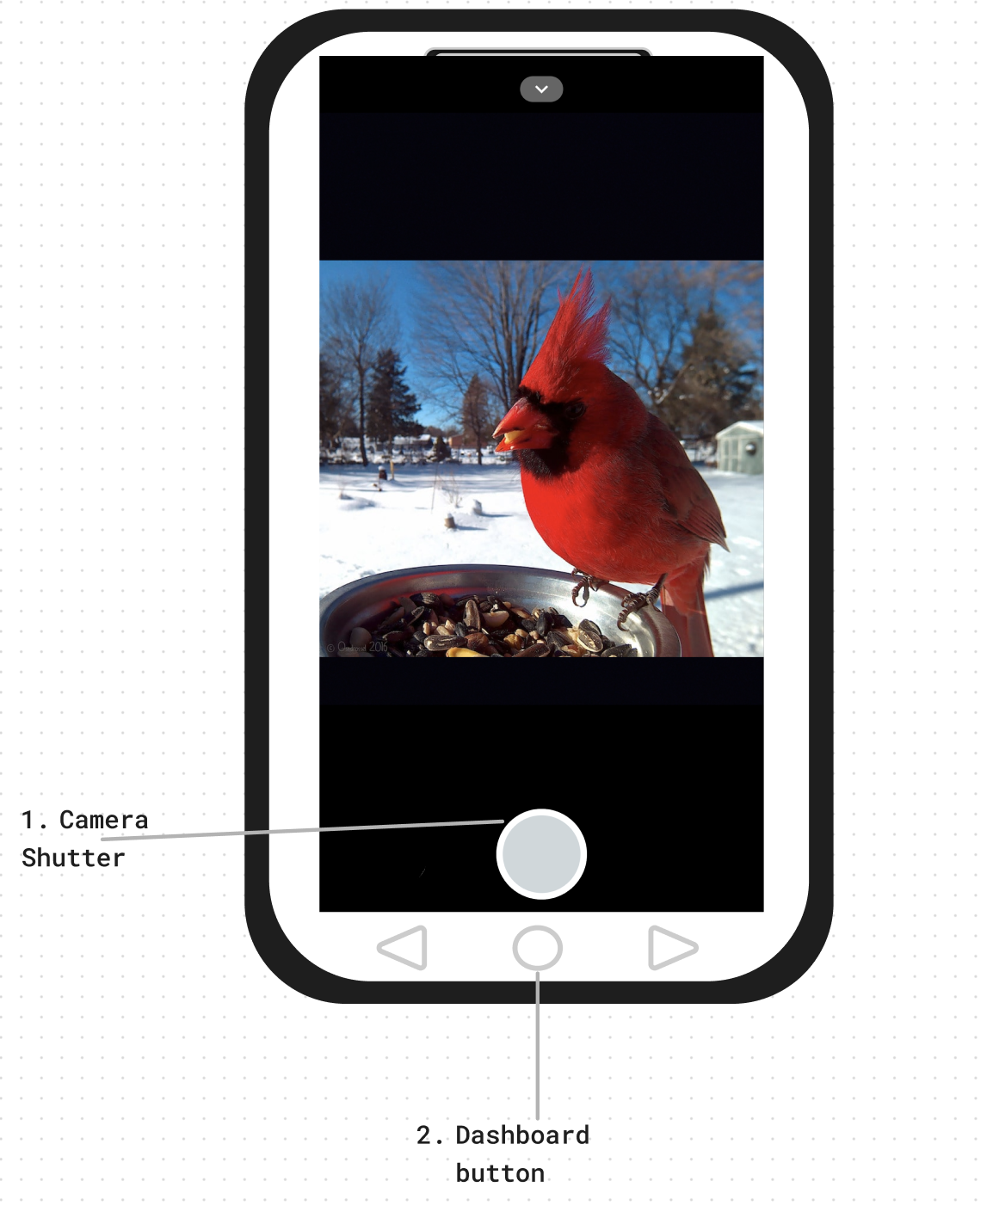

Figure 5: Camera (Dongho Kim)

Researchers and viewers can access this page by the camera icon or the camera menu from the User Dashboard page. User will be prompted to a camera page implemented by Android camera API, users can take photos with camera shutter **(1)**, after taking the photo, the taken photo will be displayed and users will have an option to “use” the photo that they have just taken or “retake” the photo again. When “use” is selected this will feed the selected photo to the Tensorflow API and return the detected bird info page, displaying the matching bird info. Users can return to the Dashboard page anytime with dashboard button **(2)**.

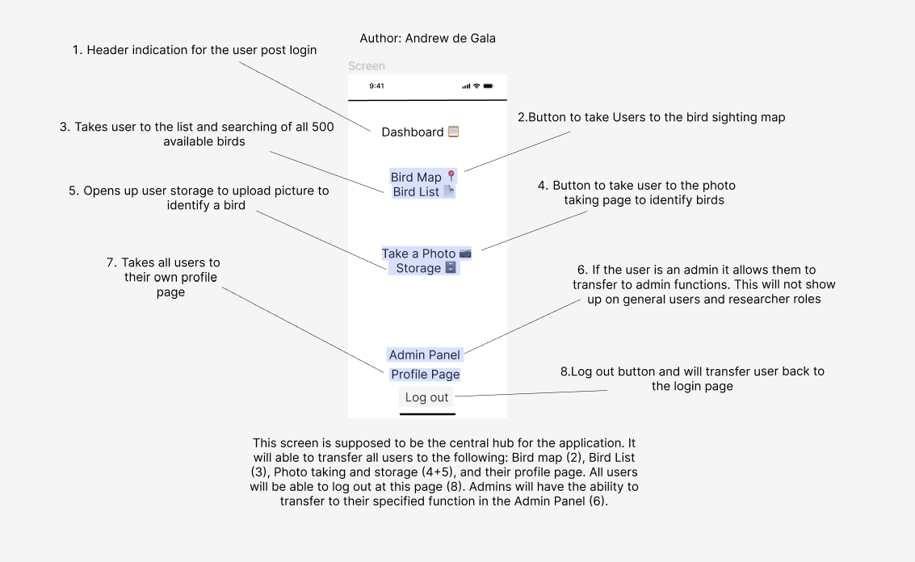

Figure 6

Authored by Andrew de Gala

This screen is supposed to be the central hub for the application. It will able to transfer all users to the following: Bird map (2), Bird List (3), Photo taking and storage (4+5), and their profile page. All users will be able to log out at this page (8). Admins will have the ability to transfer to their specified function in the Admin Panel (6).

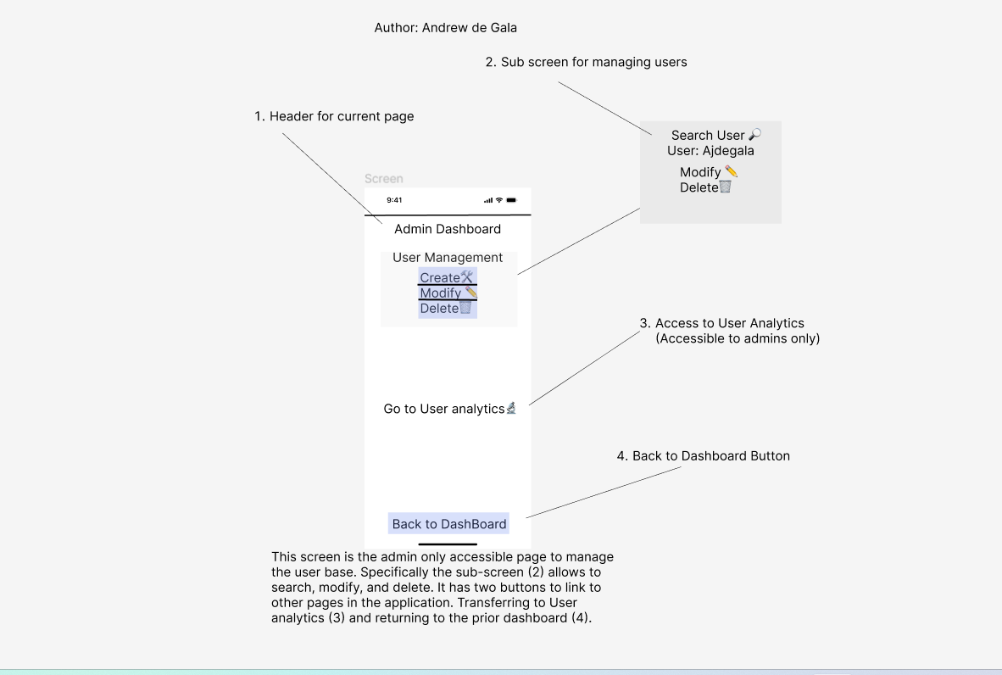

Figure 7

Authored by Andrew de Gala

This screen is the admin only accessible page to manage the user base. Specifically the sub-screen (2) allows to search, modify, and delete. It has two buttons to link to other pages in the application. Transferring to User analytics (3) and returning to the prior dashboard (4).

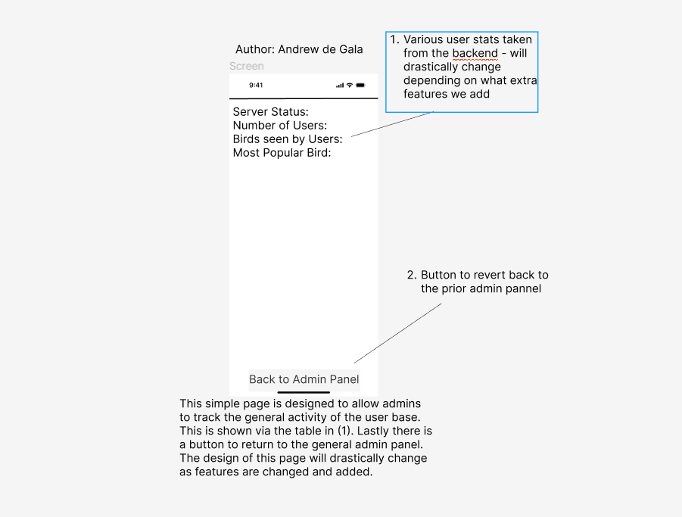

Figure 8

Authored by Andrew de Gala

This simple page is designed to allow admins to track the general activity of the user base.  
This is shown via the table in (1). Lastly there is a button to return to the general admin panel. The design of this page will drastically change as features are changed and added.

Figure 9

Authored by Siddhartha Gudipudi

This is a simple profile page. Every user has a profile page which has the information about the username and email primarily. This page also contains a profile logo, which can be edited to the initials(for example S G – for me) if interested. It also has a back button to go back to the dashboard. The general settings include info about the user if any added, privileges that the user has(say, viewer, researcher, admin), a change password button to change the password of the account logged in, a Logout button to log out of the account and it takes the user back to the login page where he can get in with the same or different account. Lastly a written statement of the name of the app and the version to include some professionalism in the view.

Figure 10

Authored by Siddhartha Gudipudi

This is a birds list page. In this page users can see all the birds and search for any specific birds they are looking for. This page has a back button to go back to the previous page. The search bar helps users to search for a particular bird they want. The photo of the bird gives the users a good idea of how the bird look and is some times necessary as some users search for a photo to know the bird name and info. The view detail button navigates the users to the bird info page after clicking on it. The bird info page gives the information of the birds. The scroll bar is a initiated to know the page length and number of birds remaining. Lastly the page has a home button which navigates the user to the dashboard when clicked.